Setting up Application Environment Create Flask Project

Team ID

Project Name

PNT2022TMID18116

Skill and Job Recommender Application

**Step 1.** Install Python latest version from python.org

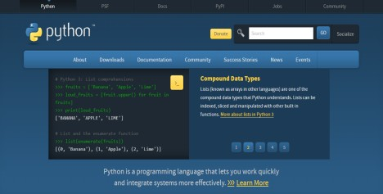

**Step 2**. Download Anaconda from [https://www.anaconda.com/](http://www.anaconda.com/) and install it by running the .exe file



**Step 3**.Install Flask using command pip install flask

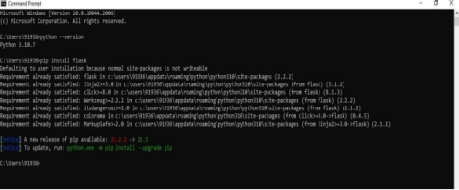

**Step 4**. Open a new Python file and start coding app.py

from flask import Flask app=Flask(name)@app.route('/') def hello():

return "Hello World" if name =='main':

app.run(debug=True)

**Step 5**. Run the Python file using command python filename.py

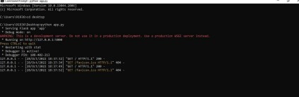

**Step 6**: Open the Ip in browser

